Jean Rhaye Christopher T. Mendoza IT-3107

WEKA Lab Exercise

PART 1:

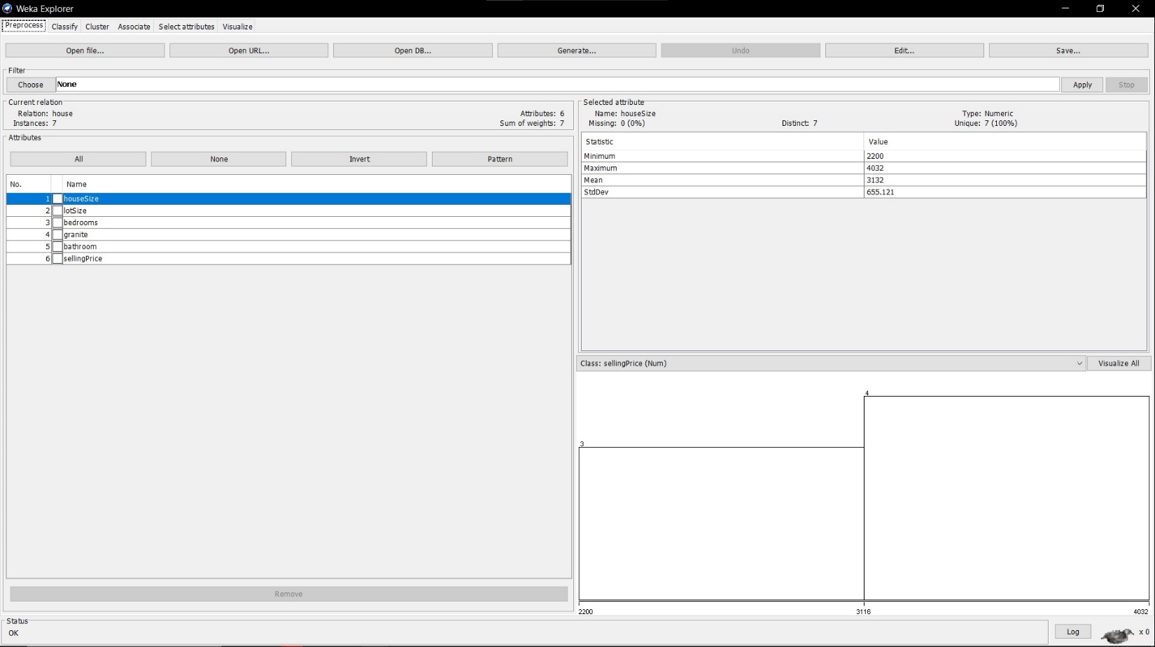
Load Houses
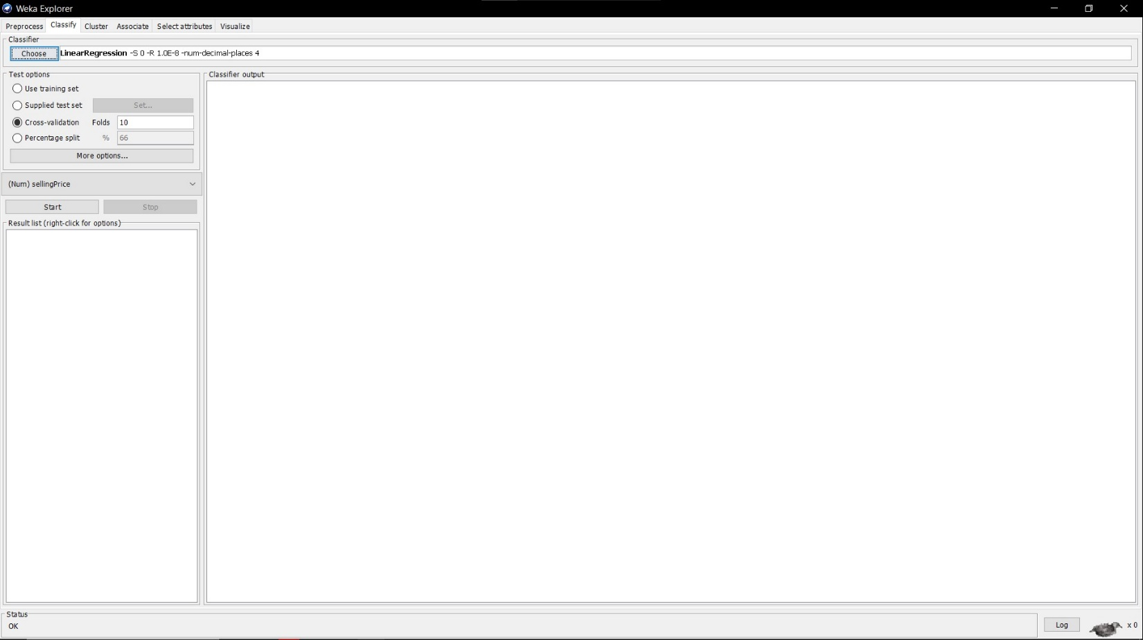
Linear Regression Classifier

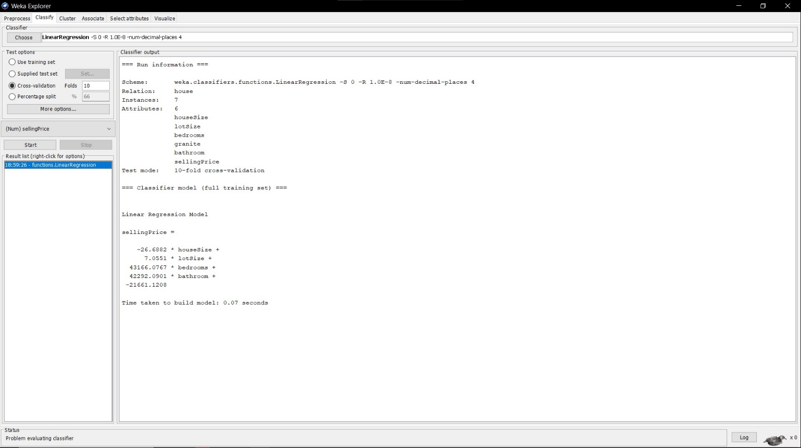
Selling Price Start Build
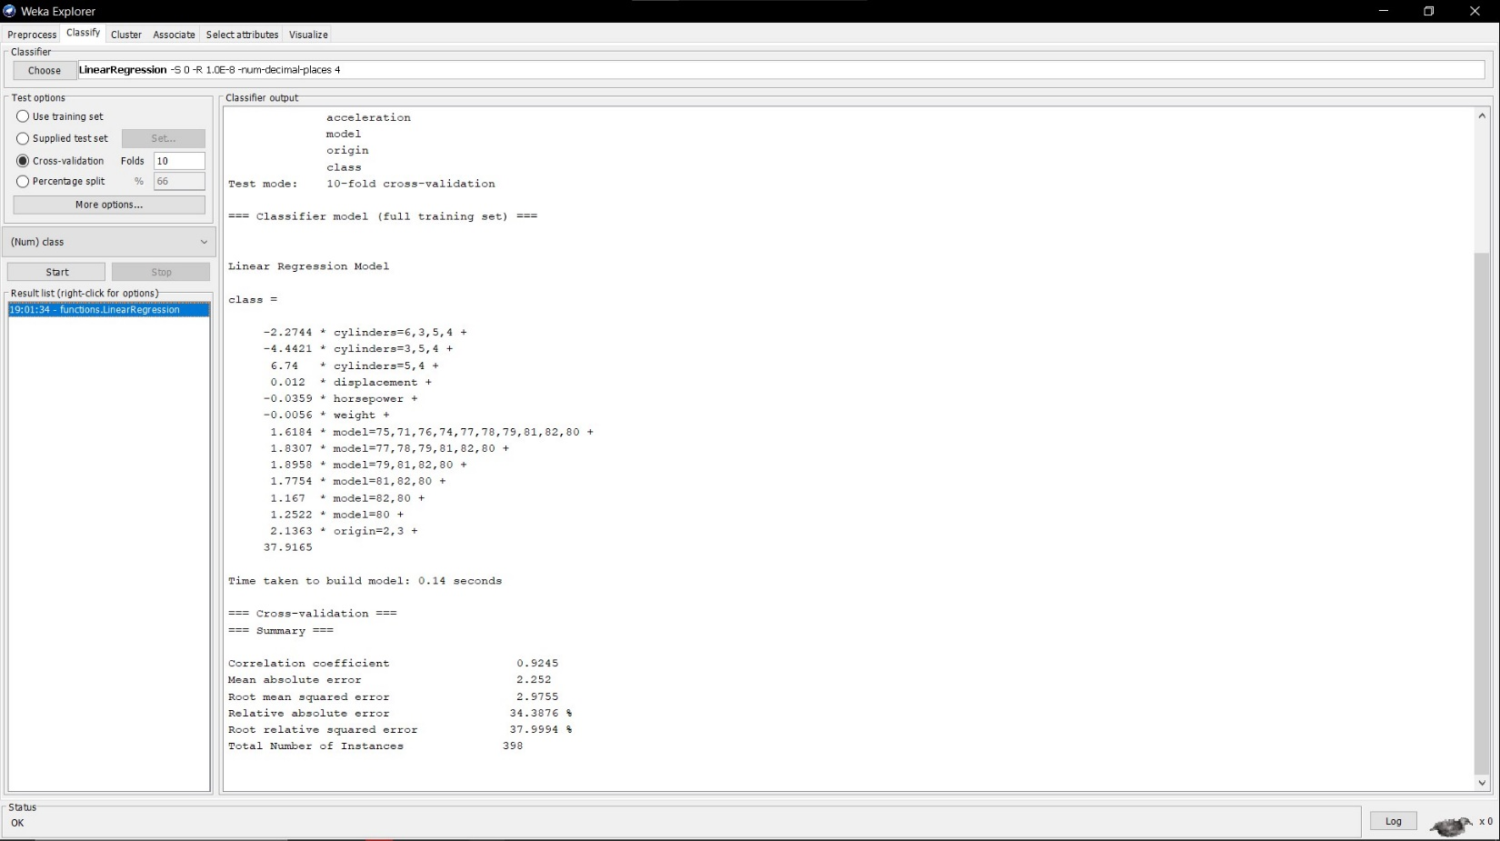
Load AutoMPG and Class Start Build

PART 2:
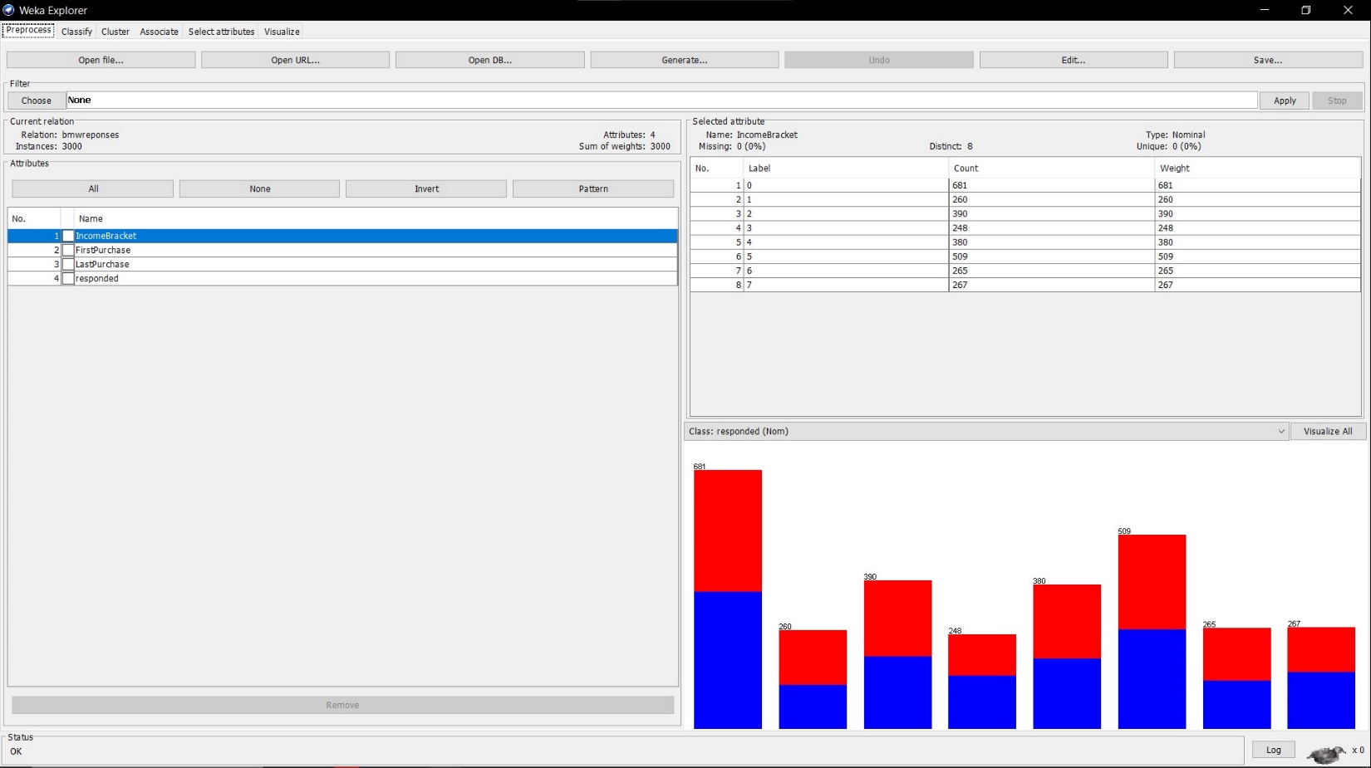
Load BMW Training

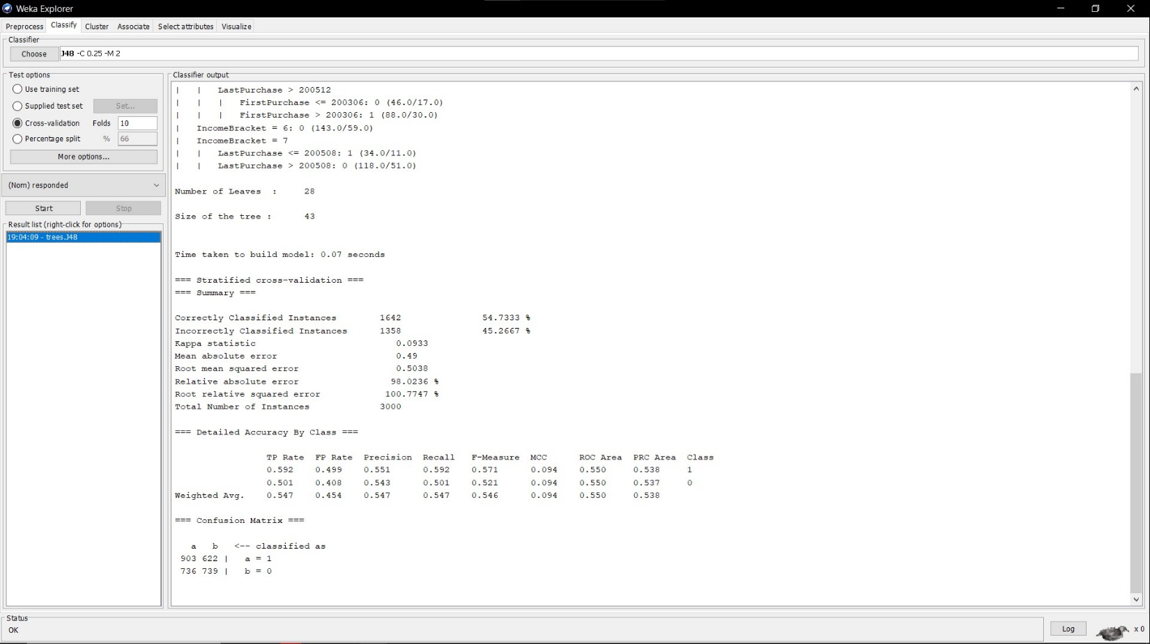
Responded Start Build
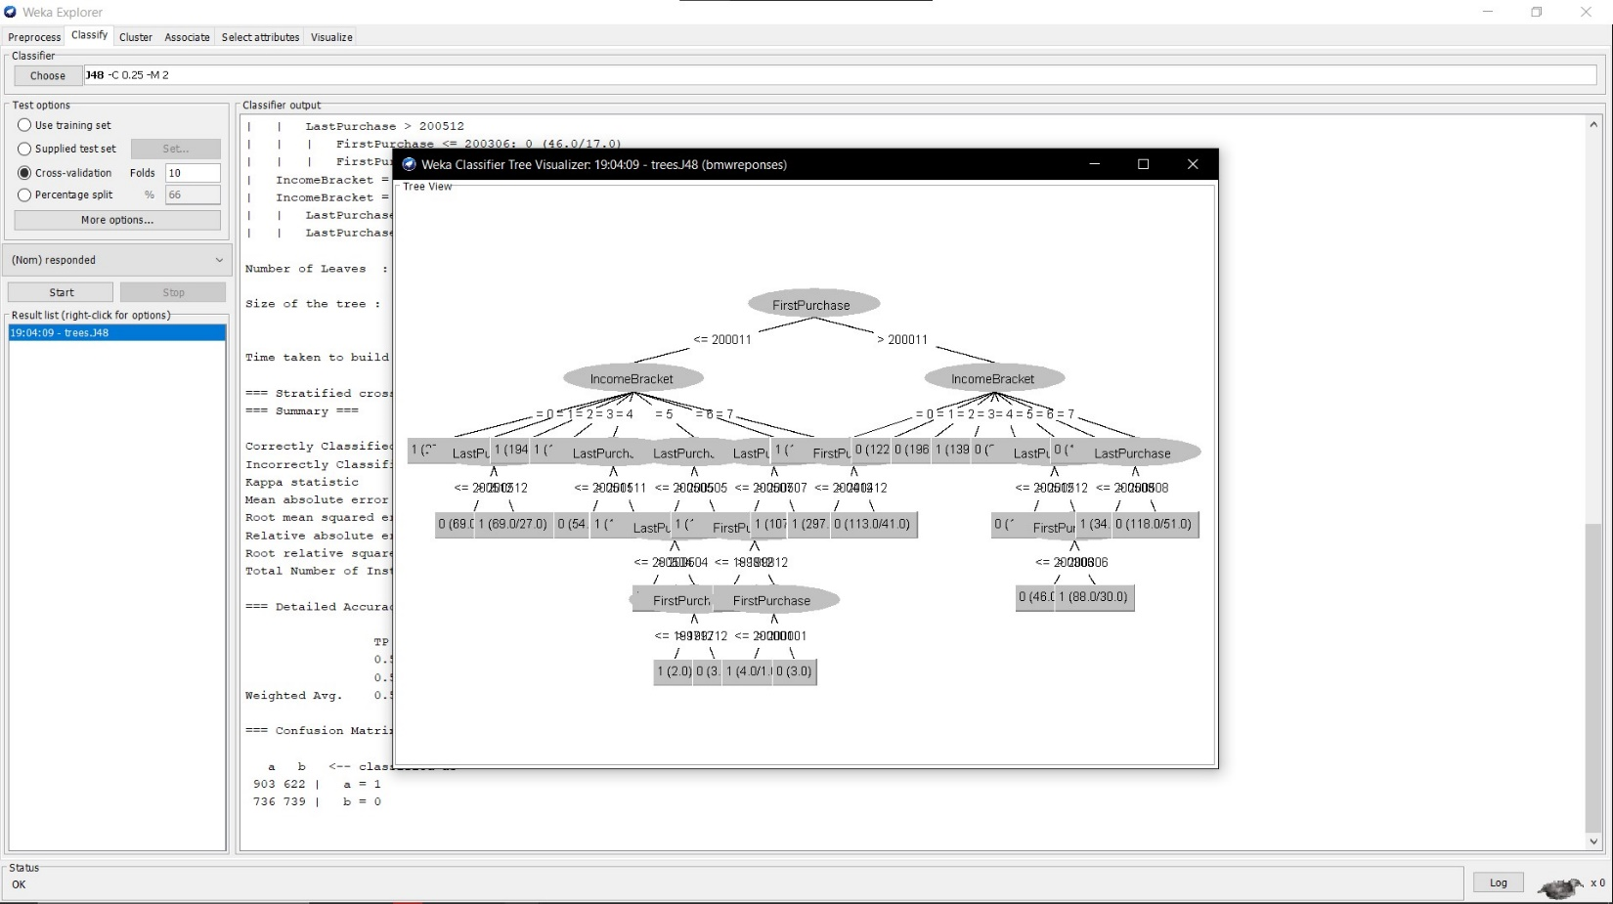
Visualize Tree
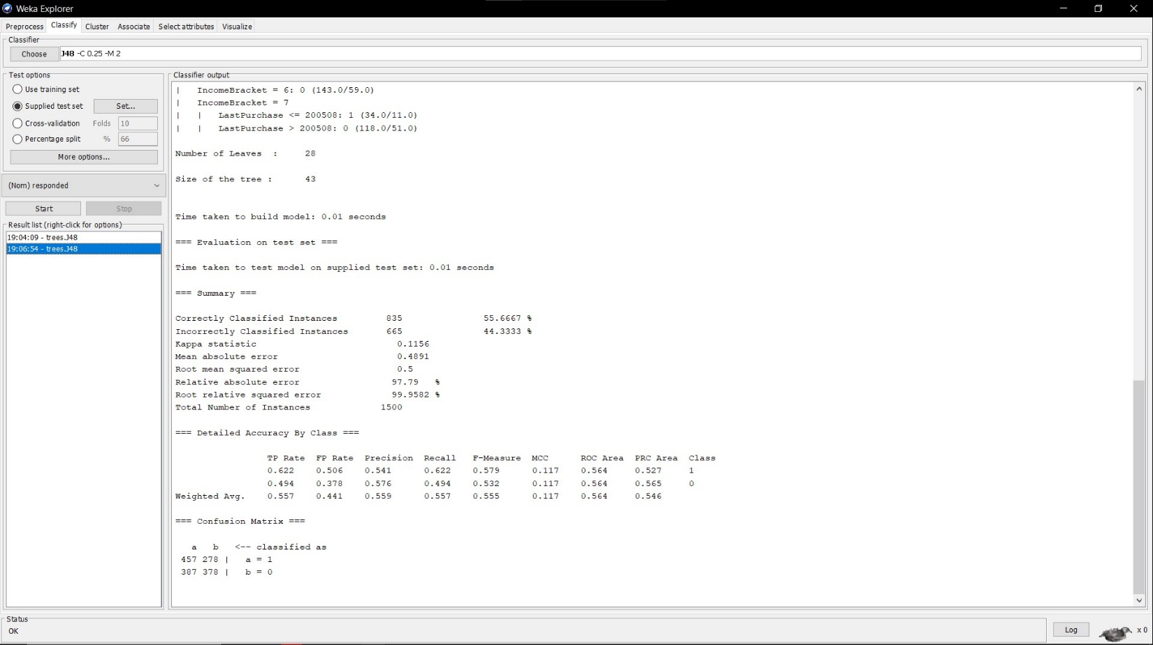
Load BMW Test Set and Start Build

